CA1

Data Application Development

Wayne Hartigan (x16348136)

## Foundation 1



As some values were to be set as unknown, I set them as N/a to be easily cleaned up later on

## Foundation 2



I am now left with Marital, Default, Housing, Loan, Campaign and Euribor3m with N/a values.

## Foundation 3



## Foundation 4



I searched for outliers in the age category as it would be the only one I feel that would have a meaningful outlier, there were many outliers so I decided I would not remove them as that would skew the data too much

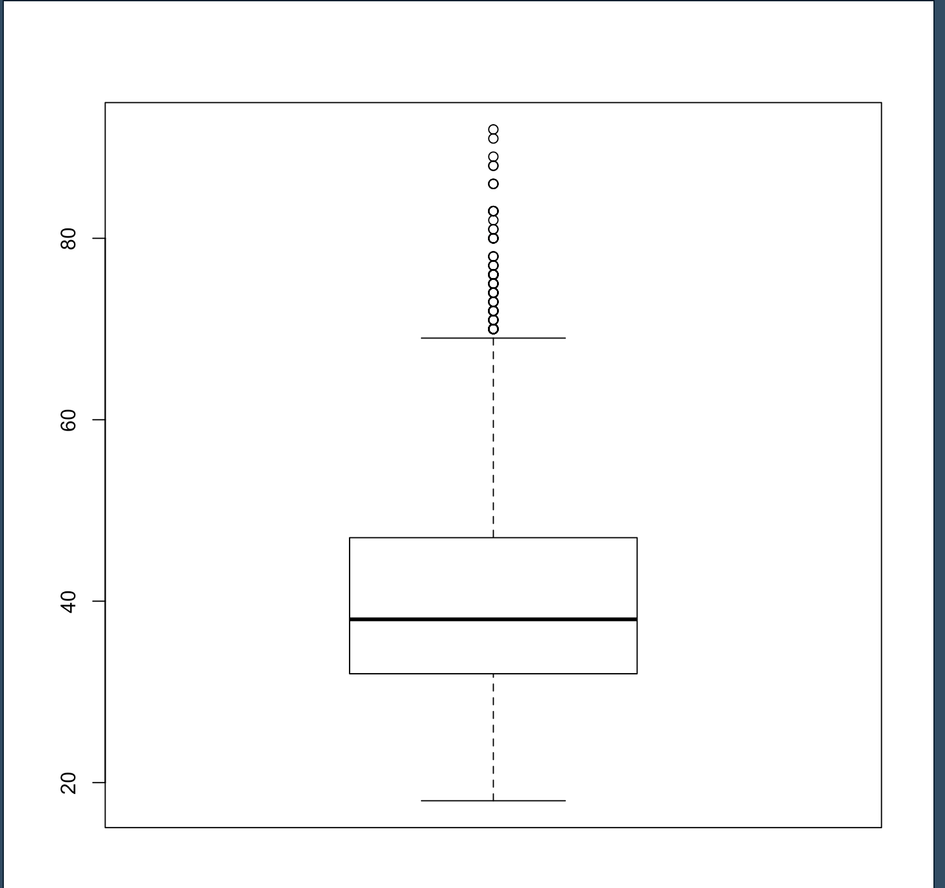

## Advanced 1A

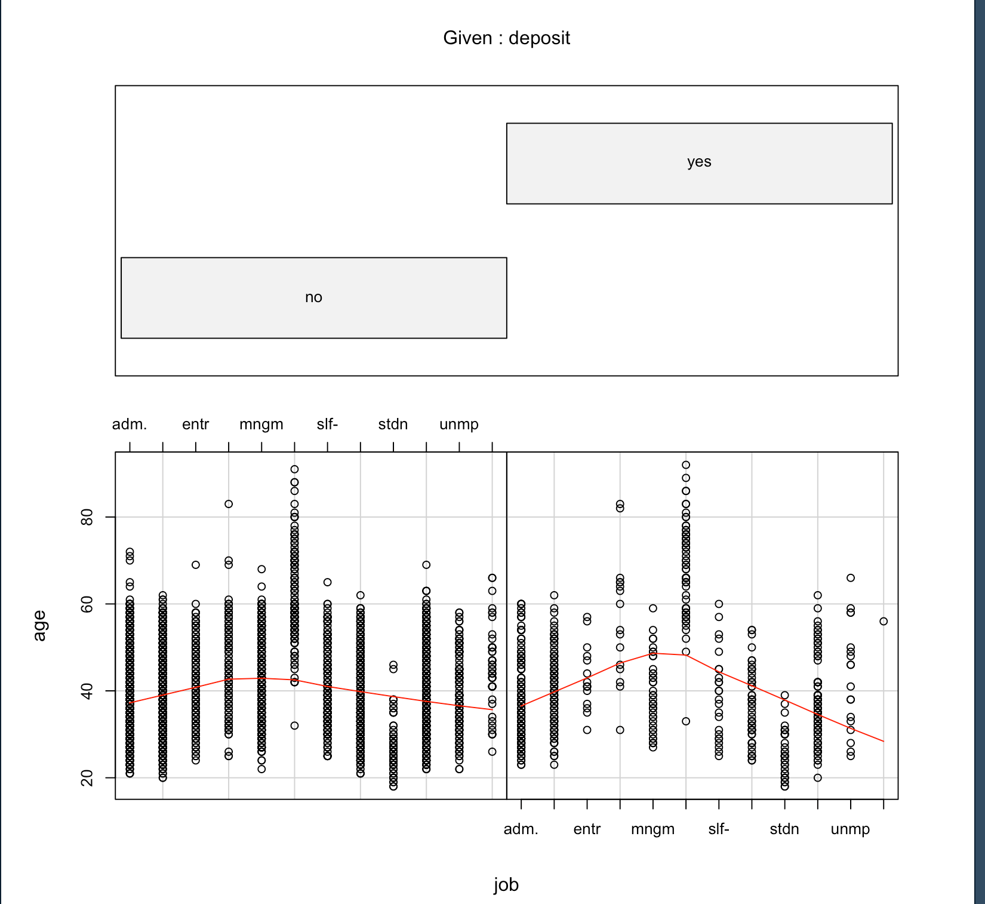

Very clearly from this graph, people who are unemployed/students tend to not give a deposit. Most unemployed/students tend to be younger as well.

## Advanced 1A

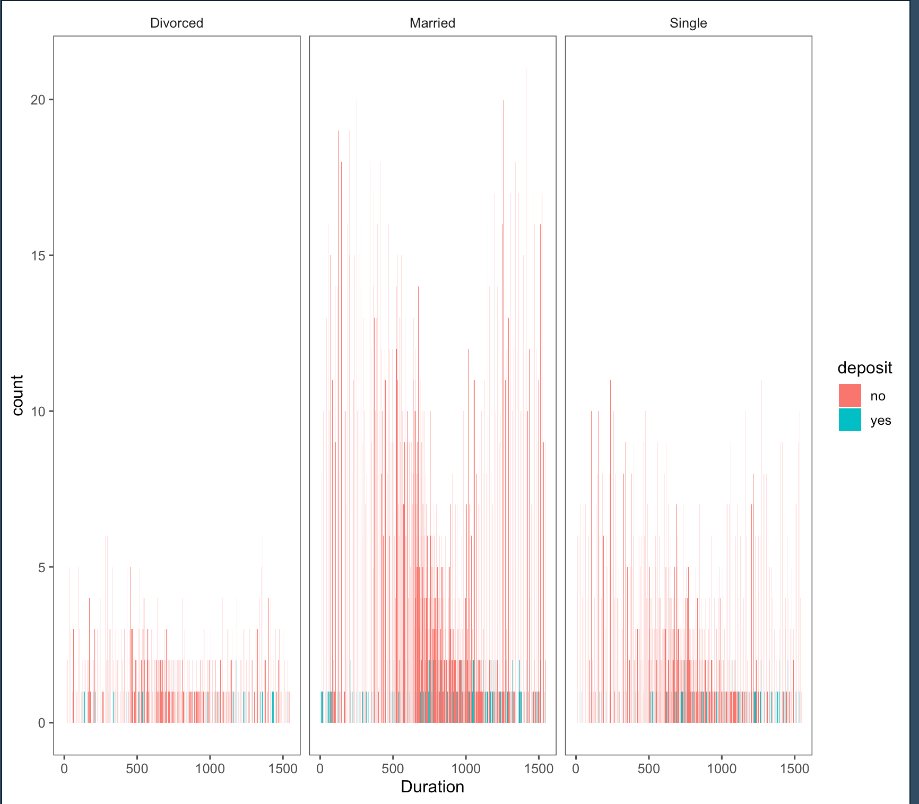

Surprisingly people are married tend to not have paid a deposit, and tend to have a short duration, compared to divorced who have very little data.

## Advanced 2

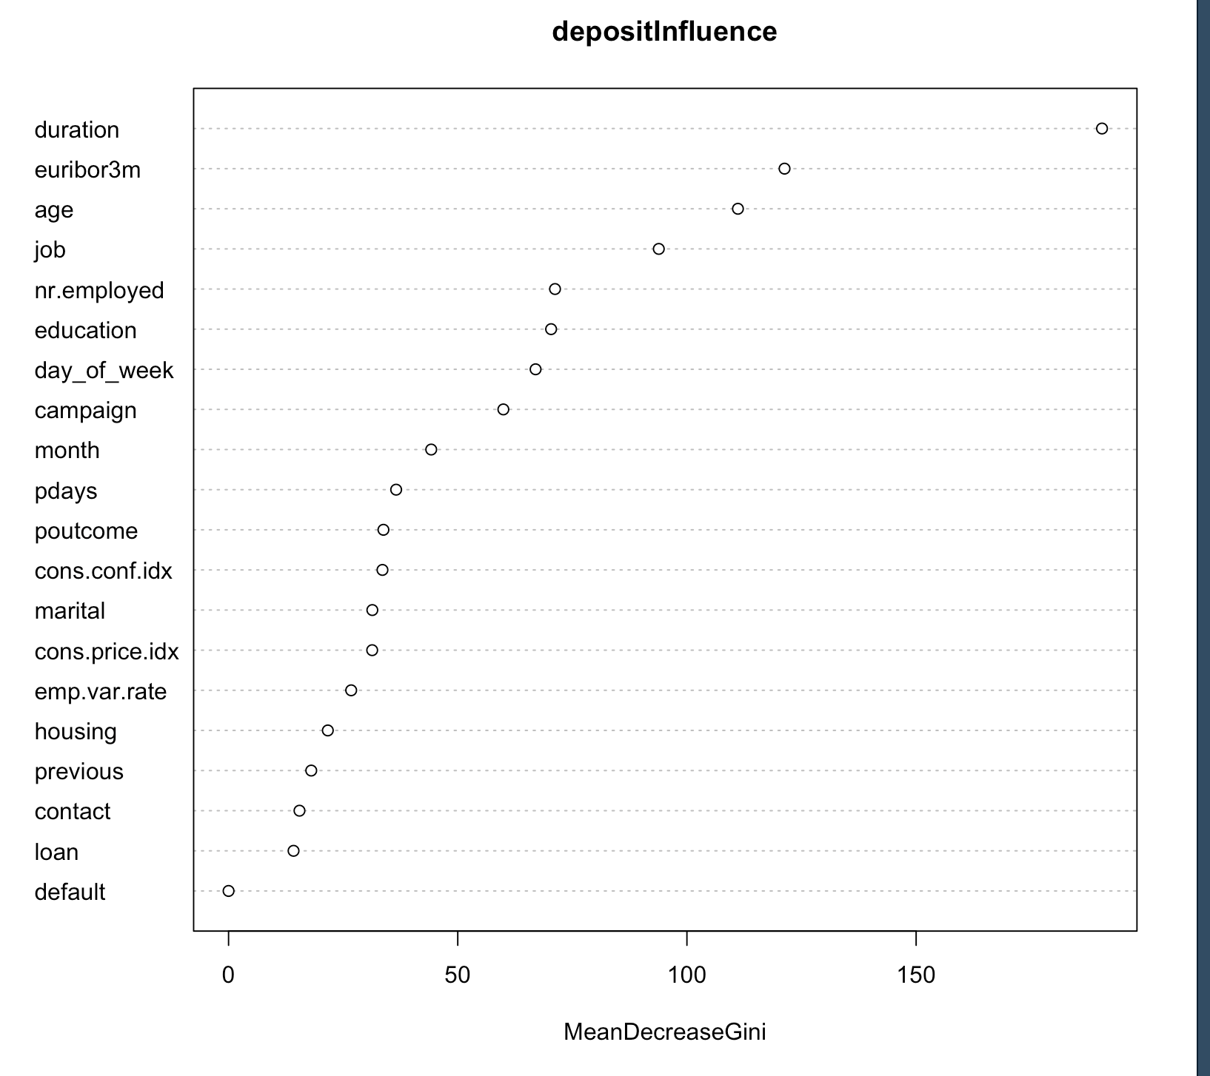

Duration clearly has the biggest impact, but also age has a very big impact on deposit which is understandable as the older you are the more time you have to save.

## Advanced 3

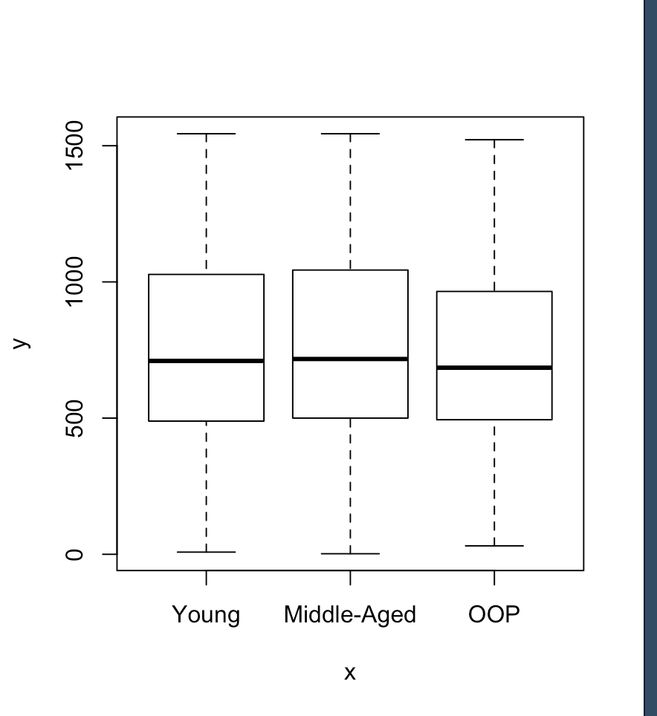

I split the age groups into 18, 35, 60, 92, as the youngest was 18 and the oldest was 92 and I decided that 35 & 60 were good splitting points between the min/max.

From the output, the ”young” group tend to spend less time on the phone that “middle-aged”, which is understandable as younger people would use the internet more often and expectedly OOP spend less time on the phone that both Younger and Middle-Aged.